PREALGEBRA – “EQUATION, FRACTIONS, ETC…”

1. Find the value of: 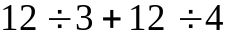

a) b) c) d) 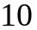 e) NOTA

2. Solve: 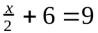

a) b) 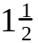 c)  d) 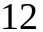 e) NOTA

3. Simplify: 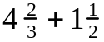

a) 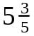 b) 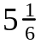 c) 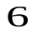 d) 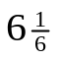 e) NOTA

- Find the Greatest Common Factor for 112 and 144

a) b) c) 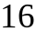 d) 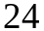 e) NOTA

5. Translate this phrase into an algebraic expression: “the difference of x and 6”

a) 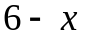 b) 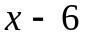 c) 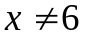 d) 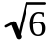 e) NOTA

6. Evaluate: 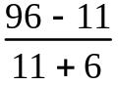

a) b) c) d) e) NOTA

7. Simplify: 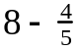

a) 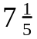 b) 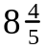 c) 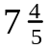 d) 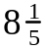 e) NOTA

8. Solve: 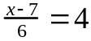

a) 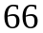 b) 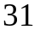 c) 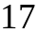 d) e) NOTA

9. Simplify: 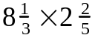

a) 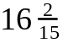 b) c) 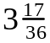 d)  e) NOTA

- Tuy builds a model of the Pentagon for his social studies project. The length of each side is 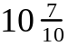 inches. What is the total perimeter?

a) 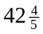in. b) 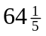in. c) 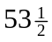 in. d) 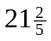 in. e) NOTA

11. Solve: 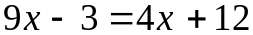

a) b) c) 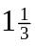 d) e) NOTA

12. Simplify: 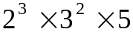

a) 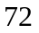 b) 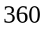 c) 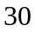 d) 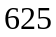 e) NOTA

13. Simplify: 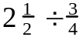

a) 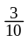 b) 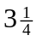 c) 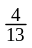 d) 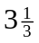 e) NOTA

- Evaluate 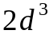 if 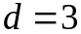

a) 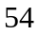 b) 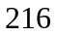 c) 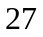 d) 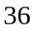 e) NOTA

- What is the quotient if the eighth term of the sequence 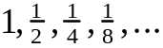 is divided by the ninth term?

a) b) c) d) e) NOTA

- If a number is multiplied by itself and doubled, the result is 72. What is the number?

a) b) c)  d) e) NOTA

17. Evaluate: 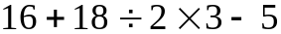

a) 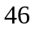 b) 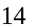 c) 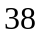 d) e) NOTA

- Find the sum of all the whole number factors of 96

a) 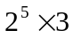 b) 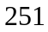 c) 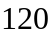 d) 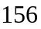 e) NOTA

19. Which of the following is divisible by both 3 and 8?

a) 222222 b) 388888 c) 444444 d) 765432 e) NOTA

20. Simplify: 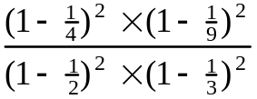

a) b) c) d) e) NOTA

- Express 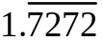 as an improper fraction

a) 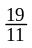 b) 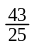 c) 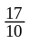 d) 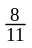 e) NOTA

22. Simplify: 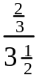

a) b) 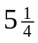 c) 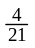 d) 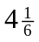 e) NOTA

23. Solve: 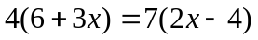

a) b) 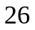 c) 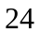 d) 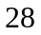 e) NOTA

- Find the total fare for a 3 mile taxi ride if the rates are:
- $1.35 for the first mile
- $ .80 for the next mile
- $ .35 for each additional mile (or fraction thereof)

a)  b) 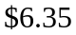 c) 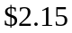 d) 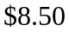 e) NOTA

25. Simplify: 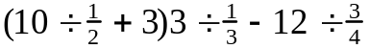

a) 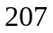 b) c) 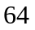 d) 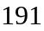 e) NOTA

26. Solve: 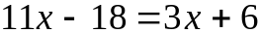

a) b) c) d) e) NOTA

- Crape myrtle shrubs make up of the shrubs in Gwen’s yard. Of these are white. What portion of the shrubs in Gwen’s yard are white crape myrtle shrubs?

a) b) c) d) e) NOTA

- Larry bought some plant food that weighed 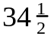 ounces. He divided the plant food into piles of equal weight. How much did each pile weigh?

a) oz. b) 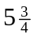 oz. c) 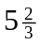 oz. d)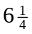 oz. e) NOTA

- Connie owns a total of 63 books. She has 13 more paperback books than hardcover books. How many hardcover books does she own?

a) 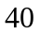 b) c) 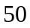 d) 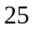 e) NOTA

30. Simplify: 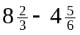

a) 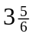 b) c) 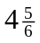 d) 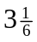 e) NOTA

Answers For Pre-Algebra Individual
EQUATIONS, FRACTIONS, ORDER OF OPERATIONS

- B
- A
- D
- C
- B
- D
- A
- B
- D
- C
- A
- B
- D
- A
- D
- E
- C
- E
- D
- C
- A
- C
- B
- B
- D
- A
- C
- B
- D
- A

